7th Grade Science
Class Meeting Time(s) - TBD
2020-2021

Teacher Name | Email Address | Phone Number | Office Hours
Mr. Sunda | sundar@gcsnc.com | 919-764-4183 | TBD
Mr. Powell | powelld2@gcsnc.com | 336-937-0633 | TBD

- Sending an email is the quickest way to get a response!

Sign up for my Remind 101 for important updates by texting @8k9e7g8 to 81010
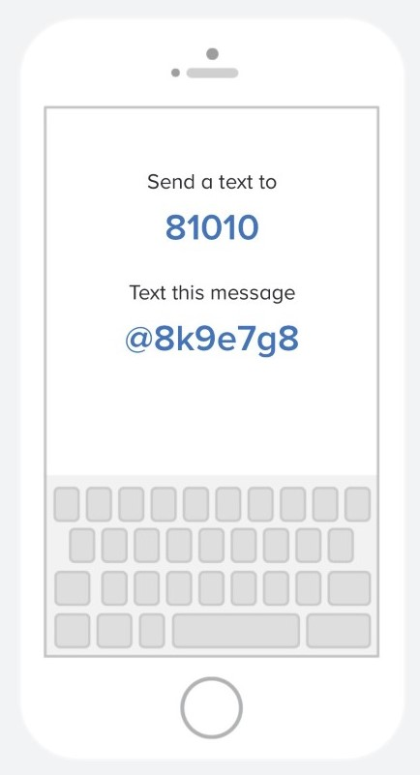

Introduction
Welcome to an exciting new school year at Otis L. Hairston Middle School. My name is Mr. Sunda and I will be your 7th Grade Science teacher. I am a graduate of Harvard College and this is my second year of teaching science at Hairston. The best part of teaching is getting to know of all my students and ask awesome questions about science.
This science class is designed to help students learn more about how the field of science impacts their everyday lives by forming our own questions and sharing our ideas. This year you can expect to engage with your teacher and the class through a variety of online platforms. Instructions will be posted in Canvas so make sure you read the expectations of each assignment carefully! Because we are a community of learners, please also expect to work periodically in group situations and to present information to your peers in groups or individually.
To gain access to my Canvas page, go to https://idp.ncedcloud.org/idp/AuthnEngine#/authn and enter the following information:
Username: Student Lunch Number
Password: Jaguar2020

Standards and Units of Study
7th Grade Science will focus on five primary units of study, as outlined in the North Carolina 7th Grade Science Standard Course of Study (to view the North Carolina 7th Grade Science Standards CLICK HERE). This course will show relevance to student learning and understanding of the course content applied in the real world.
Units of focus:
- Earth Systems, Structures, and Processes 2. Forces and Motion
3. Energy: Conservation and Transfer
- Structures and Functions of Living Organisms 5. Evolution and Genetics
Materials

- Pencils and Erasers
- Notebook
- Graph Paper
- GCS Tablet

Assignments
All assignments will be listed in Canvas. To access the assignments, click on the month, then week. Here you will see a suggested schedule for completing lessons and assignments. The schedule will also include the due date for each assignment. All assignments should be submitted in Canvas by 9:59 p.m. on the due date.
Live Sessions
Dates and times of live sessions will be included in the weekly schedule. During this time, we will teach lessons, answer student questions, work in small group, or students will complete assessments. Attendance is required, and students will adhere to the School’s code of conduct. Students are expected to be civil and respectful. The student will be asked to use the hand-raise button when he/she wishes to speak to help make sure everyone has a chance to speak. Students will post respectful comments in the chat box.
Grading Policy
1. Tests: (35%)
Tests are generally scheduled at the end of each chapter/unit. Students will only be allowed to take a test during live sessions. Failure to complete a test will result in a grade of zero for that test.
2. Quizzes: (25%)
Quizzes will generally be given at least once a week. These assessments consist of no more than 8 problems and can be made up if your first grade is a D or lower. Quizzes must be taken on the day they are assigned.
3. Practice: (30%)
Practice will generally be assigned in each lesson. It is very important you attempt to answer all of the questions to the best of your ability and refer to the notes, text, or video provided during the lesson for help. Immediate feedback (24-48 hours) will be given for all practice assignment; therefore, students will have an opportunity to improve practice assignment grades throughout the week.
4. Team Project: (10%)
Each term, students will have one project that involves them applying one or multiple skills learned in class to the real world. Each project will be accompanied with a rubric outlining the expectation. Students will work as a team to complete the project and the projects will be posted on the School’s Website for public viewing.

Grading Scale
A – 90% - 100%
B – 80% - 89%
C – 70% - 79%
D – 60% - 69%
F – 59% and below

Absences/Make-Up Work
It is very important that you log into Canvas on time everyday and participate in class in order to pass. Please ask the teacher about any assignments missed if you must be absent. You are responsible for the work you miss. Making up assignments is at the teacher’s discretion. No extra credit will be given.

Inclusive Learning Environment Statement
The best learning environment––whether in-person or virtual instruction, is one in which all members feel respected while being productively challenged. At Hairston Middle School, we are dedicated to fostering an inclusive atmosphere, in which all participants can contribute, explore, and challenge their own ideas as well as those of others. Every participant has an active responsibility to foster a climate of intellectual stimulation, openness, and respect for diverse perspectives, questions, personal backgrounds, abilities, and experiences, although instructors bear primary responsibility for its maintenance.
A range of resources is available to those who perceive a learning environment as lacking inclusivity, as defined in the preceding paragraph. If possible, we encourage students to speak directly with their teacher about any suggestions or concerns they have regarding a particular instructional space or situation. Alternatively, students may bring concerns to another trusted adult (such as an counselor, social worker, teacher, or administrator).
Academic Honest Policy
International Baccalaureate Academic Honesty Policy Handbook
Hairston Middle School recognizes and follows the academic honesty policy set forth by the IBO for the Middle Years Program. Plagiarism is recognized worldwide as a serious academic offense. Ignorance of the working definition of plagiarism is not a valid excuse for lapses and does not prevent penalty from being applied to work submitted as original. With that being said, Hairston Middle School teachers and staff will continually work with students to provide them with definitions of academic malpractice and plagiarism, but also outline strategies to prevent it. Our goals throughout a student's educational experience at HMS concerning academic honesty are to teach the IBO definitions of plagiarism, collusion, and malpractice, and help make aware the expectations of behavior that is responsible and ethical.

Some highlights from the IB Academic Honesty Policy above include:

- Candidates are required to act in a responsible and ethical manner throughout their participation in the Diploma Program and examinations.
- Candidates must avoid malpractice, which is defined by the IBO as any behavior that results in, or may result in, the candidate or any other candidate gaining an unfair advantage in one or more assessment components, including:
  - Plagiarism, which is the representation of the ideas or work of another person as the candidate's own.
  - Collusion, which is knowingly supporting the malpractice activities of another candidate, as in allowing one's work to be copied or submitted for assessment by another
  - Duplication of work, which is the presentation of the same work for different assessment components and/or Diploma Program requirements
  - Other misconduct during an IB examination session, including taking unauthorized material into an examination, participating in behavior that disrupts or distracts other candidates, or communicating with another candidate.

If a case of malpractice has been established, no grade will be awarded in the subject(s) concerned and the student must complete the assignment under the supervision of an authorized adult.
Disclaimer
The teacher reserves the right to make modifications to this information throughout the school year.

